Descriptive Statistics

Descriptive Statistics

• These are used to describe the samples you are concerned with.

• They are used for – Getting the ‘feel’ of the data ; for use in the statistical tests themselves.

• Example – When you guide a friend coming for the first time to your home about the time it would take to reach from his/her home is a ‘mean’ value of travel time. The more often you have taken the journey earlier, the better would be the estimate.

• Say, you suggest that it would take 50 minutes to reach, give or take 10 minutes either side, traffic permitting. This is an estimate of ‘standard deviation’

Measures of central tendency

• Suppose the lengths of sample western painted turtles from a data set are – 28.5, 18.75, 22.9, 25.4, 25.4, 23.7, 23.9 cms.

• Mean: 24.078 

• Median: 23.9

• Mode:25.4

Disadvantages of averages

• Averages do not tell the whole story

• Averages are susceptible to outliers. Outliers skew the averages and pull them in their direction

• Averages make us believe that data points are clustered around a point higher or lower than where they truly cluster

• Averages do not account for segments in data

Measures of dispersion

• Range is the simplest measure of variation. It is the difference between the highest value and the lowest value in the data set. • Interquartile range describes the middle 50% of the values when ordered from lowest to highest.

• To calculate the IQR, we find the median of lower half and upper half of data. These are quartile 1 and quartile 3. The IQR is the difference between quartile 3 and quartile 1. IQR is resistant to outliers.

• Variance is the summed average squared difference of values from the mean.

• Standard deviation is calculated is the square root of variance.

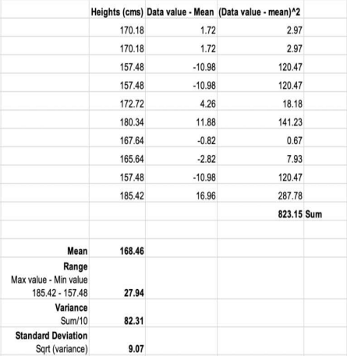

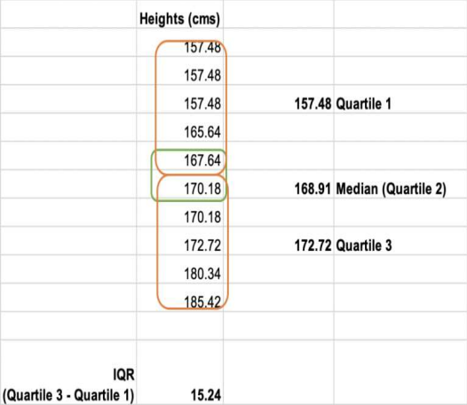

Skewness

• Skewness means lack of symmetry. In statistics, a distribution is called symmetric, if mean, mode and median coincide.

• If the right tail is longer, we get a positively skewed distribution. • If the left tail is longer, we get a negatively skewed distribution

Symmetric and Skewed Distribution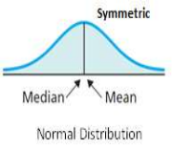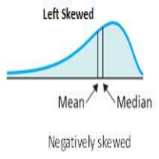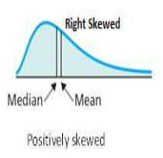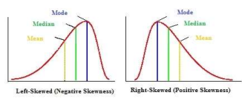

Kurtosis

• Epistemology – Kurtos is a Greek word meaning curve or arch

• Kurtosis is a statistical measure that identifies whether the tails of a given distribution contain extreme values.

• Data sets with high kurtosis tends to have heavy tails or outliers • Data sets with low Kurtosis tends to have light tails or outliers

Kurtosis Terminologies

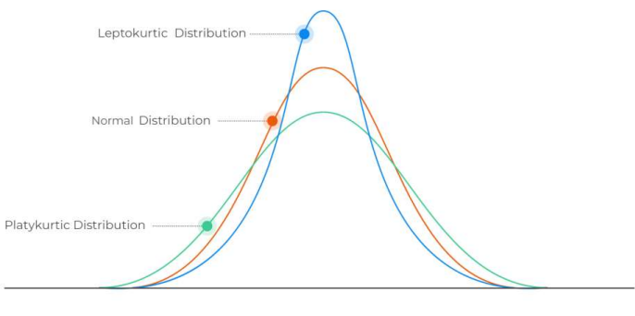

MS- EXCEL descriptive Statistics toolbox

• https://www.socscistatistics.com/utilities/normaldistribution/default. aspx is an online calculator to produce some normally distributed data

• MS-EXCEL – Data – Data analysis

• Choose Descriptive statistics – Choose input Range, Output Range details

• Excel produces all descriptive statistics

| Data |
| --- |
|  |
| Mean -0.26 |
| Standard Error 0.089 |
| Median -0.25 |
| Mode 0.15 |
| Standard Deviation 0.89 |
| Sample Variance 0.792 |
| Kurtosis -0.14 |
| Skewness -0.24 |
| Range 4.59 |
| Minimum -2.91 |
| Maximum 1.68 |
| Sum -26 |
| Count 100 |

Economic Applications

• Financial Markets

• Kurtosis isn’t just a theory confined to mathematical textbooks; it has real life applications, especially in the world of economics. Fund managers usually focus on risks and returns, kurtosis (in particular if an investment is lepto- or platy-kurtic). According to stock trader and analyst Michael Harris, a leptokurtic return means that risks are coming from outlier events. This would be a stock for investors willing to take extreme risks. For example, real estate (with a kurt of 8.75) and High Yield US bonds (8.63) are high risk investments while Investment grade US bonds (1.06) and Small cap US stocks (1.08) would be considered safer investments.

• *Ref.: https://www.statisticshowto.com/probability-and-statistics/statistics-definitions/kurtosis-leptokurtic-platykurtic/*